Intra-operative measurement of biaxial strains of the ascending thoracic aorta based on video-tracking

Shaiv Parikh¹, Berta Ganizada², Gijs Debeij², Ehsan Natour², Jos Maessen², Tammo Delhaas¹, Wouter Huberts¹, Elham Bidar², Koen D Reesink¹
1. Department of Biomedical Engineering,
2. Department of Cardiothoracic Surgery,
CARIM School for Cardiovascular Diseases and Heart and Vascular Center, Maastricht University Medical Center+, Maastricht, The Netherlands.

Word count: ###
Number of Figures: 2
Number of Tables: 1

Corresponding author:
Koen D. Reesink, PhD
Dept. of Biomedical Engineering
CARIM School for Cardiovascular Diseases
Maastricht University Medical Center +
Universiteitssingel 50, room H3.360
Phone: +31 6 4216 1888 / secretariat: + 31 43 388 1659
k.reesink@maastrichtuniversity.nl

Abstract

…
Introduction
Ascending thoracic aortic aneurysm formation is a lethal disease, which necessitates surgical intervention to prevent death due to dissection of the aorta and/or rupture [1, 2]. The etiology of aneurysm formation and the pathways leading to rupture or dissection are still poorly understood. It is therefore difficult to predict whether an asymptomatic aneurysm is likely to rupture or dissect, and whether an immediate but risky intervention is needed. In current clinical practice, the decision for surgical intervention is based on maximum diameter (>= 5.5 cm) and growth rate (>1 cm/year) of the aneurysm [2, 3, 4]. However, considering just aortic size and growth rate as predictors for rupture/dissection results in 60% of unexpected dissections [3], while another study indicated rupture occurs in 0.3% cases for diameters <4 cm and 1.7% cases for diameters <5 cm [5]. These clinical metrics do not consider vessel wall mechanics and undermine the role of vessel wall’s microstructural integrity [3]. However, aortic wall deformations induced by the pulsating blood pressure can provide more insights into degenerative changes taking place in the aortic wall in terms of differences in stiffness [5].
Most of the clinical literature makes use of changes in lumen area with respect to changes in aortic pressure and a simplified constitutive model to estimate local material stiffness of the aorta [3, 7]. However, these approaches neglect longitudinal deformations, while recent studies have shown that longitudinal strain is present in the aorta due to the movement of the sinotubular junction (STJ) and serves as an independent measure of aortic pathophysiology [7, 8]. Moreover, accurate wall stress prediction in the aortic wall is dependent on its inherent biaxial anisotropy due to the interaction of elastin and collagen fibers. Therefore, to estimate wall stresses, biaxial deformation estimates are of prime importance [9]. The presence of deformations in two directions, i.e. circumferential and longitudinal strains, in combination with the anisotropic nature of the aortic wall, advocates for the quantification of biaxial aortic deformations when aiming for the estimation of tissue stiffness.
Existing methods to capture biaxial deformations of ascending aorta are based on noninvasive MR, CT and US imaging [7, 8, 10, 11]. However, MR- and CT-based longitudinal strain measures are global in nature because they are obtained by assessing the displacement of the aortic root with respect to the distance between the aortic root till either the descending aorta or the brachiocephalic trunk. The latter two structures are assumed to be fixed points in space during the cardiac cycle [7, 8, 10]. Furthermore, for the strain calculations it is assumed that the geometry is a straight tube cylinder, and the curved shape of the aorta is neglected. However, for an accurate evaluation of the mechanics of the pathology, more localized strain estimations should be made because an aneurysm is mainly characterized by a local vessel dilatation. In addition, there is no need to assume a straight cylindrical geometry as required by the MR and CT-based methods. On the other hand, US imaging has been successfully applied for local strain measurements [11, 12]. However, use of transthoracic US probe results in lack of accessibility and low image quality of the ascending aorta [11]. Use of transesophageal probe pre-operatively has also demonstrated abilities to determine biaxial deformations of the ascending aorta [12]. Nevertheless, due to presence of artifacts in the image quality, led to inaccuracy in motion estimation and ultimately overestimation of the shear modulus of the ascending aorta [12]. We believe that the limitations posed by current imaging modalities to assess biaxial mechanics of the thoracic ascending aorta could be overcome by accessing the aortas of the wide patient population undergoing elective open thorax surgeries. Capturing the videos of aortas during intra-operative procedures and tracking its motion would resolve the issues of local region definition and image quality posed by other imaging modalities.
Therefore, in this study, we aimed to develop an intra-operative method that can assess local biaxial strain estimations of thoracic ascending aortas in vivo. Our method is based on a video of the thoracic aorta with markers placed on top that are tracked automatically by a state-of-the-art algorithm. The method will be applied to patients undergoing aneurysm repair procedures, coronary artery bypass procedures or aortic valve replacements. Ultimately, it can serve as validation methodology for the development of non-invasive methods.

Methods

Study population
We recruited study participants from the list of consecutive patients scheduled for elective open-thorax surgery. Prior to enrolment, patients gave written informed consent. The study was approved by the Maastricht University medical ethics committee.
In total, 30 patients are included in the present analysis, with specific indications: aneurysm repair (n = 15), coronary artery bypass grafting (CABG, n = 12), and aortic valve replacement (AVR, n = 3). Videos of patients where tracking of markers was not accomplished – either due to high de-correlation noise (n=1) or loss of visibility of the tracking marker in all frames (n=1), were excluded.

Video-based biaxial strain method description
Figure 1 illustrates the key elements of the presented method. The biaxial strain method includes video recording, felt tracking, displacement measurements, filtering and strain assessments, which are further detailed below.
Intra-operative set-up and video recording settings
A camera mounting arm was secured to the surgical table at the head end (Fig. 1A) during the routine clinical preparations for open-chest surgery. The arm consisted of a commercial action cam extension arm (GoPro stick, GoPro Inc., San Mateo, CA) and a custom mounting bracket suited to the bed. The rigidity of the arm made sure that the camera position with respect to the opened chest was maintained during table tilting. To prevent manual artifacts during starting and stopping the recording, remote control was obtained by connectinga smartphone with the camera via Bluetooth. The camera used was a commercial action cam (HERO7, GoPro Inc., San Mateo, CA), with the following settings: 2.7k video resolution (screen resolution in pixels – 2704 x 1520), at 50 frames per second, and linear field of view.
After surgical exposure of the ascending aortic region, four sterile surgical pledgets (BARD PTFE Felt Pledgets, Bard Peripheral Vascular, Inc., Tempe, USA) were sutured to the adventitial surface of the aorta, facilitating video tracking (Fig. 1B). In the aneurysm repair cases, one pair of markers was placed caudally and one cranially around the location exhibiting the largest diameter. The two felts of a pair were placed as diametrically opposite as possible (Fig. 1B). In the CABG and AVR cases, a similar arrangement of felts was created, with a similar spacing between caudal and cranial markers, whilst making sure the caudal markers were 1-2 cm away from the sinotubular junction. For all cases, the (axial) distance between the two pairs of markers was kept between 0.5-to-1 times the diametrical distance, as exemplified in Fig. 1B.
Just prior to recordings the camera was manually positioned to ensure that its focal plane was in parallel to the imaging plane as defined by the four markers. The distance between camera and imaging plane was about 30 cm (Fig. 1A). For calibration, a sterile steel or paper ruler was placed in the imaging plane as well.
Blood pressure conditions and recording protocol
Videos were made during both ‘low’ and ‘high' pressure conditions that were induced by table tilting (Fig. 1A). Measuring at two pressure conditions served two purposes: (1) a practical evaluation of the precision and sensitivity of our method, and (2) the changes in measured strains as caused by the change in distending pressure could provide information on the non-linear material behavior of the aorta. Systolic and diastolic blood pressure (BP) measurements were done via a pressure catheter (Edward Lifesciences, Irvine, California, United States) placed in the (left) radial artery. Subsequently, readings were taken from the clinical routine hemodynamics monitor (stored in a case report form) just prior to and directly after video recordings.
The first video recording was obtained with the patient in either supine, anti-Trendelenburg, or Trendelenburg position. The second video recording was then obtained at a different pressure level after tilting the table. The initial table position determined whether the second measurement was made with an increased or decreased BP condition, hereby utilising the expected BP differences between positioning: Trendelenburg BP > supine BP > anti-Trendelenburg BP. The sequence (low-then-high, or high-then-low) was determined by the surgeon.
Video recording duration was 12 seconds to capture at least two ventilation cycles. Two ventilation cycles were taken to assess the reproducibility of the method. The video recordings and pressure readings did not span more than 2 minutes, after which the surgical procedure continued.
In the aneurysm repair cases, the resected tissue was further sectioned and stored in vials for genetic and tissue characterization, but these data are not included in the analysis, i.e. beyond the scope of the present paper.
After the procedure, all video files (.mp4 format) and blood pressure case report forms, were stored on a secure local backup server for further processing.
Video processing and strain calculations
To determine diameters and axial lengths from acquired videos, markers on the ascending aorta were tracked across all video frames, using a proprietary programme written in MATLAB (MATLAB R2018a; MathWorks, Natick, MA, USA). The programme is avaible upon request made to the corresponding author. In the first step, the region of aorta with markers and ruler was selected manually using the imrect MATLAB function. The coordinates of the same imrect box were translated automatically to all frames of the video, hence, defining the regions of interest in all the video frames. Only those regions of interest were further analyzed. Subsequently, a small region within or at the boundary of the markers were manually selected using the MATLAB function imellipse to define a fingerprint of the markers (sub images) that will be used for correlation with all the regions of interest in all the video frames. To find the correlation between the sub images (markers) and (reduced) video frames the normalized cross correlation matrix is computed by using the MATLAB function normxcorr2 (Fig. 1B). Coordinates of the sub images in each frame are then defined as those where the normalized cross-correlation coefficient is maximum. Using the obtained positions of the markers in all video frames, the distances between markers as function of time were determined, yielding diameter (D) and axial length (L) over time (illustrated in Fig. 1C and E).
To calibrate the measured distances, a known reference distance visible on the ruler in a video frame (in cm) was used. The reference distance was measured by placing markers on the corresponding ticks of the recorded ruler in one of the video frames. The calibration factor was defined as the ratio between the number of image pixels and the reference distance in m. Note that calibration is relevant for the diastolic diameter (D_{d}) and length (L_{d}) but not for the strain estimates (see calculations below).
The D and L signals can be decomposed to the summation of (co)sines with different frequencies by using the well-known Fourier series. The lowest frequency of each signal was in the order of 0.2 Hz and therefore identified as the one produced due to ventilation (Fig. 1C and F). Each ventilation cycle was extracted manually from the raw D and L signals and smoothed, using a zero-phase digital filter (filtfilt, MATLAB R2018a; MathWorks, Natick, MA, USA) with filter coefficients a = 1 and b = 1/6*[1 1 1 1 1 1], resulting in an effective cut-off frequency of 3.5 – 4Hz. The start and end points for ventilation cycle and single beat were selected manually using the MATLAB function ginput. The signal values between those start and end points were then identified by the algorithm and subsequently the ventilation cycle and a single heartbeat were segmented. After beat segmentation, the beat-by-beat minimum and maximum points were determined, yielding respectively diastolic values (D_{d} and L_{d}) and the deformations (ΔD and ΔL). The circumferential strains and axial strains were then calculated for each beat as the relative deformations (ΔD/D_{d}) and (ΔL/L_{d}), respectively (Fig. 1D and F). Lastly, the diastolic dimensions and strains were averaged over the number of beats by taking the median values. The two ventilatory cycles (Fig. 1C and E) present in every recording were considered as repeated measurements, to assess reproducibility (see below).

Statistical analysis
Data are presented as median [IQR], unless noted otherwise. Non-normality of presented measurement datasets was confirmed using Shapiro – Wilk test.

Based on the two ventilatory cycles in each recording (see above), the intra-measurement SD was determined as the square root of the average of variances of the repeated measurements for each recording:
σ_{intra} = _{√(}∑ s_{i}²/n)
with ∑ s_{i}²/n, the average of variances for n subjects (i = 1 to n, number of subjects)
We expressed reproducibility as coefficients of variation (CV%), defined as the intra-measurement standard deviation divided by the corresponding group mean value ( μ ), times 100%:
$\text{CV} \text{= }\frac{{\text{σ}}_{\text{intra}}}{\text{μ}}\text{x 100}$ %
We tested for statistical differences between low- and high-pressure conditions by performing a paired Wilcoxon Signed-Rank test.

Results
Table 1 shows the BP and video-derived measurements. In one subject we did not obtain video results during the high-pressure condition, due to loss of view on one marker (hence n=29 analyzed). There were two subjects in which the ruler appeared not visible well enough. In these cases, the felt marker dimensions (48 mm x 60 mm) were used for calibration instead of the ruler.
Diastolic and systolic blood pressures changed significantly between low and high-pressure conditions.
In contrast, the absolute dimensions (D_{d} and L_{d}) and strains (ΔD/D_{d} and ΔL/L_{d}) did not change significantly with pressure conditions.
No significant difference was observed between circumferential strains (caudal and cranial), and axial strains (medial and lateral) for low-pressure condition, while both the strain estimates varied significantly for high-pressure condition (Figure 2).
For all measures, the CV remained below 20%.

Discussion
In the present study, we introduce and characterize an intra-operative method for the local assessment of biaxial strains of the thoracic ascending aorta. Results show the ability to capture local circumferential and axial strains with acceptable reproducibility, in patients with and without aneurysm. The low cost and high accessibility of our method makes it feasible for larger cohort and multi-center studies.
Novelty of the method
Our approach differs from existing methods reported in previous studies [7, 8], where global rather than local longitudinal deformations were quantified. These global approaches consider the aortic root at one end and the brachiocephalic bifurcation at the other end as the region of interest. Our method enables measurement of axial strains of particularly aneurysmatic region of the ascending aorta.
The longitudinal strains obtained using the global approaches resulted in mean values of the order of 6 - 9% [7, 8] in pathological conditions, and of the order 15% for healthy volunteers [8], while our local strains were of the order of 4 – 5%. Higher strains in global approaches may be explained by the presence of non-diseased tissue along with diseased tissue in the region of interest, while in our approach the region of interest is localized on the diseased portion (in case of aneurysm patients) of aorta only, which is generally characterized by higher material stiffness. Moreover, the axial stiffness for the global region of interest would be lower for a given axial length (l) as compared to local region of given axial length (l1), with l > l1, since the axial stiffness is inversely proportional to axial stiffness.

In addition to global definition of region of interest, both studies idealize the aortic segment into a cylindrical geometry without considering potential difference between medial and lateral side of the ascending aorta due to lack of anatomical landmarks. Our method does enable to look at these differences since feature tracking points are defined by the felt markers. We expected, that owing to the bent nature, complex deformation, and material heterogeneity of the aorta, there might be differences in the medial and lateral length strains. From figure 2, it is evident, no significant differences were observed between medial and lateral length axial strains for low pressure condition, while medial and lateral strains differed by 1% for high-pressure condition.

Circumferential strains observed with the global approaches were of the order 7.7 – 13.8%, while we observed that the mean circumferential strains to be of order 2-3%. The lower values of circumferential strains due to local approach could be explained by the effect of out of plane motion of aorta during the cardiac cycle, which was not considered in the present study. The effect of out plane motion on accuracy and precision of strain values requires further investigation.

Limitations/practical (challenges/considerations)
Given the novelty of this study, we encountered some practical limitations. Major factors influencing the CV are - myriad of image intensities present in the video resulting from real operating conditions, and manual selection of the sub images for normalized cross-correlation process. Manual selection of sub images would result in variation in pixel intensities of selected regions each time, thereby affecting the correlation matrix and hence the position of the markers, giving rise to measurement noise. Nonetheless, the precision of the method attributed to CV values of maximum 12% for all the strain measurements except ΔD/D_{d} (cranial), and ΔL/L_{d} (lateral) with CV = 19% of mean value, affirms its suitability as a biaxial strain measurement technique. It is expected that improved image processing techniques may reduce the measurement uncertainty.
Another limitation of this intra-operative method is the placement of ruler for calibration. Due to non-uniform surface present in the open thorax where the region of interest was located, parallel placement of the ruler to imaging plane was not possible. For accurate measurements of the absolute values of D and L, the ruler has to be parallel to the imaging plane and at the same level as the markers. Going by the same logic, for out of (imaging) plane motion of the aorta, the ruler is no longer at the same level as that of markers at all times and hence, causes inaccuracies in strain measurements. Further investigation for strain inaccuracies due to out of plane motion is required.
Future scope
Precise quantification of biaxial deformations from the videos may facilitate in fitting constitutive models describing the interactions of the constituents of the artery. Biaxial deformations provide completeness in terms of data required to fit these mathematical models as opposed to deformations in circumferential direction only as in most cases [13]. Mapping of marker displacements from the videos onto finite element models using inverse analysis may also be utilized to determine material parameters of the ascending aorta.

Conclusion
Proposed intra-operative video-based method enables assessment of regional biaxial strains of the ascending thoracic aorta with acceptable precision. The method is a steppingstone towards clinically informed mechanistic in vitro studies using patient-specific tissue residues and biomechanical modelling.

Acknowledgments
The authors like to thank Ciprian Mateescu, MSc and Maarten Heusinkveld, PhD for their pioneering work on proposed intra-operative video-based method. Authors are also indebted to the research assistants, Karina X, Willemijn X, Colin X, Inez X, Anke X, Soe X, for their support in recruitment, measurements and logistics.

References
[1] Davies RR, Goldstein LJ, Coady MA, Tittle SL, Rizzo JA, Kopf GS, Elefteriades JA. Yearly rupture or dissection rates for thoracic aortic aneurysms: simple prediction based on size. The Annals of thoracic surgery. 2002 Jan 1;73(1):17-28.
[2] Coady MA, Rizzo JA, Hammond GL, Mandapati D, Darr U, Kopf GS, Elefteriades JA. What is the appropriate size criterion for resection of thoracic aortic aneurysms?. The Journal of thoracic and cardiovascular surgery. 1997 Mar 1;113(3):476-91.
[3] Martufi G, Forneris A, Appoo JJ, Di Martino ES. Is there a role for biomechanical engineering in helping to elucidate the risk profile of the thoracic aorta?. The Annals of thoracic surgery. 2016 Jan 1;101(1):390-8.
[4] Wang TK, Desai MY. Thoracic aortic aneurysm: Optimal surveillance and treatment. Cleveland Clinic Journal of Medicine. 2020 Aug 31;87(9):557-68.
[5] Elefteriades, J.A., 2002. Natural history of thoracic aortic aneurysms: indications for surgery, and surgical versus nonsurgical risks. The Annals of thoracic surgery, 74(5), pp.S1877-S1880.
[6] Karatolios K, Wittek A, Nwe TH, Bihari P, Shelke A, Josef D, Schmitz-Rixen T, Geks J, Maisch B, Blase C, Moosdorf R. Method for aortic wall strain measurement with three-dimensional ultrasound speckle tracking and fitted finite element analysis. The Annals of thoracic surgery. 2013 Nov 1;96(5):1664-71.
[7] Bell V, Mitchell WA, Sigurðsson S, Westenberg JJ, Gotal JD, Torjesen AA, Aspelund T, Launer LJ, de Roos A, Gudnason V, Harris TB. Longitudinal and circumferential strain of the proximal aorta. Journal of the American Heart Association. 2014 Dec 18;3(6):e001536.
[8] Guala A, Teixidó-Tura G, Rodríguez-Palomares J, Ruiz-Muñoz A, Dux-Santoy L, Villalva N, Granato C, Galian L, Gutiérrez L, González-Alujas T, Sanchez V. Proximal aorta longitudinal strain predicts aortic root dilation rate and aortic events in Marfan syndrome. European heart journal. 2019 Jul 1;40(25):2047-55.
[9] Duprey, A., Trabelsi, O., Vola, M., Favre, J.P. and Avril, S., 2016. Biaxial rupture properties of ascending thoracic aortic aneurysms. Acta biomaterialia, 42, pp.273-285.
[10] Morrison TM, Choi G, Zarins CK, Taylor CA. Circumferential and longitudinal cyclic strain of the human thoracic aorta: age-related changes. Journal of vascular surgery. 2009 Apr 1;49(4):1029-36.
[11] Wittek, A., Karatolios, K., Fritzen, C.P., Bereiter-Hahn, J., Schieffer, B., Moosdorf, R., Vogt, S. and Blase, C., 2016. Cyclic three-dimensional wall motion of the human ascending and abdominal aorta characterized by time-resolved three-dimensional ultrasound speckle tracking. Biomechanics and modeling in mechanobiology, 15(5), pp.1375-1388.
[12] van Disseldorp EM, Nijs J, Tan ME, van de Vosse FN, Lopata RG. Mechanical characterization of ascending thoracic aortic aneurysms using 4D ultrasound. InMate Poster Award 2014: 19th Annual Poster Contest 2014.
[13] Stålhand, J., 2009. Determination of human arterial wall parameters from clinical data. Biomechanics and modeling in mechanobiology, 8(2), pp.141-148.
[14] Rabkin, S.W. and Janusz, M.T., 2013. Aortic wall stress in hypertension and ascending thoracic aortic aneurysms: implications for antihypertensive therapy. High Blood Pressure & Cardiovascular Prevention, 20(4), pp.265-271.

Tables
Table 1 Blood pressure and video-derived measures
 | Pressure conditions |  |  | CV (%)
Measurements | Low (n=30) | High (n=29) | P value* (-) | Low | High
Blood pressure, P (mmHg)
DBP | 47 [36, 52] | 54 [47, 62] | <0.001 | 10 | 5
SBP | 84 [70, 93] | 98 [90, 105] | <0.001 | 4 | 3
Diastolic diameter, D_{d} (mm)
Caudal | 30 [25, 36] | 30 [23, 38] | 0.974 | 2 | 2
Cranial | 33 [23, 40] | 34 [23, 41] | 0.795 | 2 | 2
Circumferential strain, ΔD/D_{d} (-)
Caudal | 0.03 [0.02, 0.05] | 0.03 [0.02, 0.05] | 0.186 | 8 | 8
Cranial | 0.02 [0.01, 0.03] | 0.02 [0.01, 0.03] | 0.295 | 19 | 12
Axial diastolic length, L_{d} (mm)
Medial | 20 [17, 27] | 19 [17, 25] | 0.922 | 2 | 3
Lateral | 24 [20, 30] | 24 [19, 29] | 0.965 | 2 | 1
Axial strain, ΔL/L_{d} (-)
Medial | 0.04 [0.02, 0.08] | 0.05 [0.02, 0.1] | 0.007 | 10 | 11
Lateral | 0.04 [0.01, 0.05] | 0.04 [0.02, 0.06] | 0.3 | 19 | 12
Values are indicated as mean ± SD; CV = coefficient of variation [(intra-SD/mean) *100%]; DBP = Diastolic blood pressure; SBP = Systolic blood pressure; *values compared for low pressure vs. high pressure conditions using paired Wilcoxon Signed-Rank test (performed on 29 subjects); n = number of subjects.

Figures
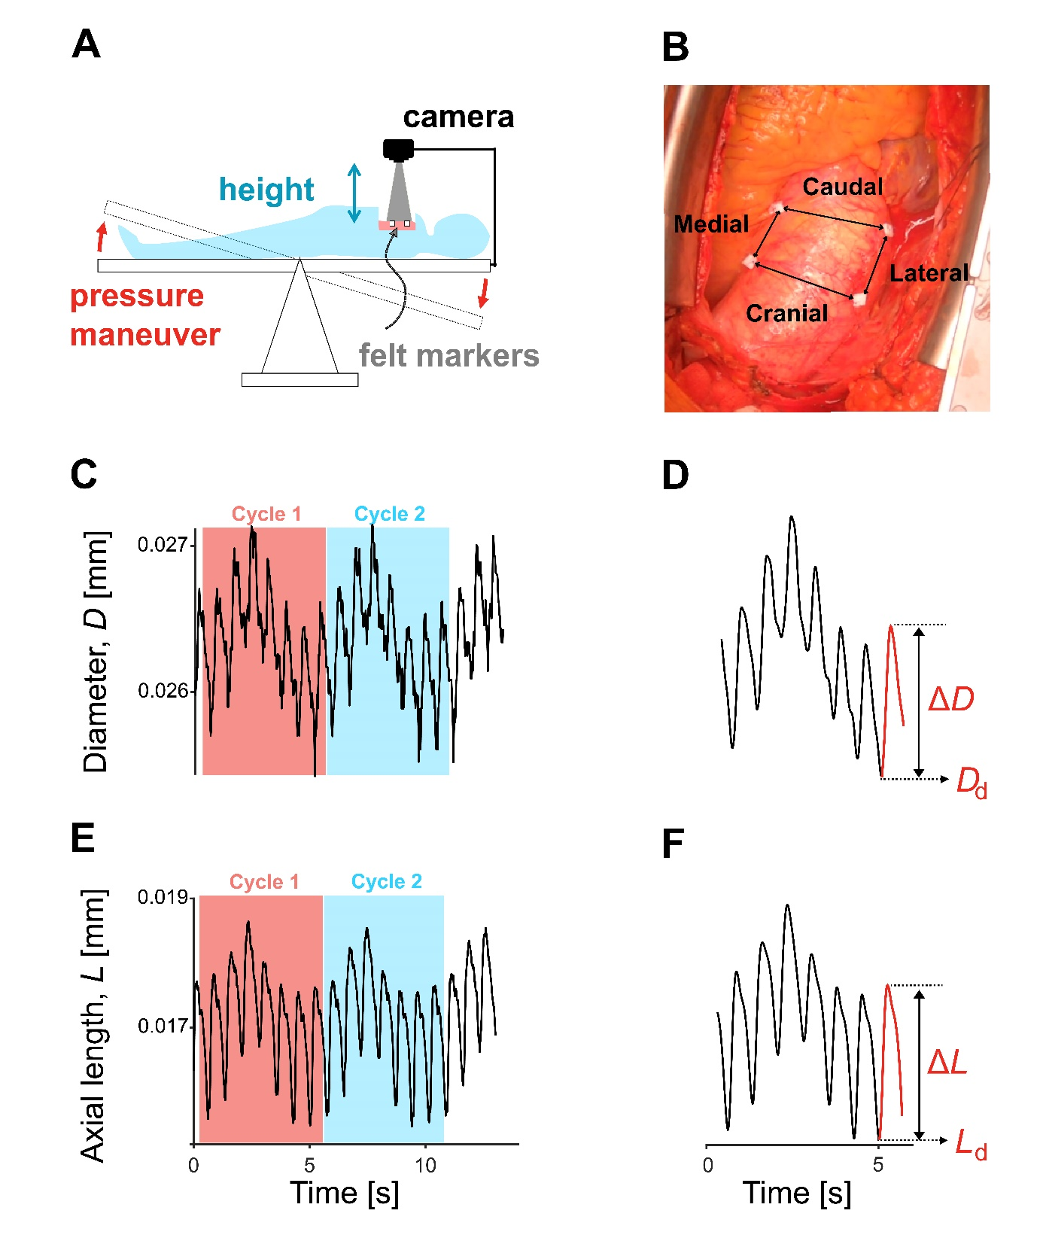
Figure 1. Key elements of the intra-operative video-based strain measurement method. A: Intra-operative set-up. The remote-controlled camera mounted on a rigid arm attached to the table is positioned at a height of about 30 cm above the imaging plane, as defined by the felt markers, with a viewing angle close to zero degrees. Low and high transmural pressure conditions were created by tilting: illustration shows the maneuver from low to high. B: Single video image showing heart on top and felt markers sutured on the adventitia of an ascending aortic aneurysm. Arrows between markers define the positions at which cranial and caudal (circumferential) strains, and medial and lateral axial strains are assessed. C and E: Example of raw signals of diameter and axial length variations, comprising of two ventilatory cycles. D and F: Smoothened raw for each ventilation cycle of diameter and axial length, respectively. The variables D_{d} and L_{d} represent magnitudes of diameter and axial length corresponding to diastolic pressure, while ΔD and ΔL are deformations of diameter and axial length caused by change in pressure from diastole to systole.

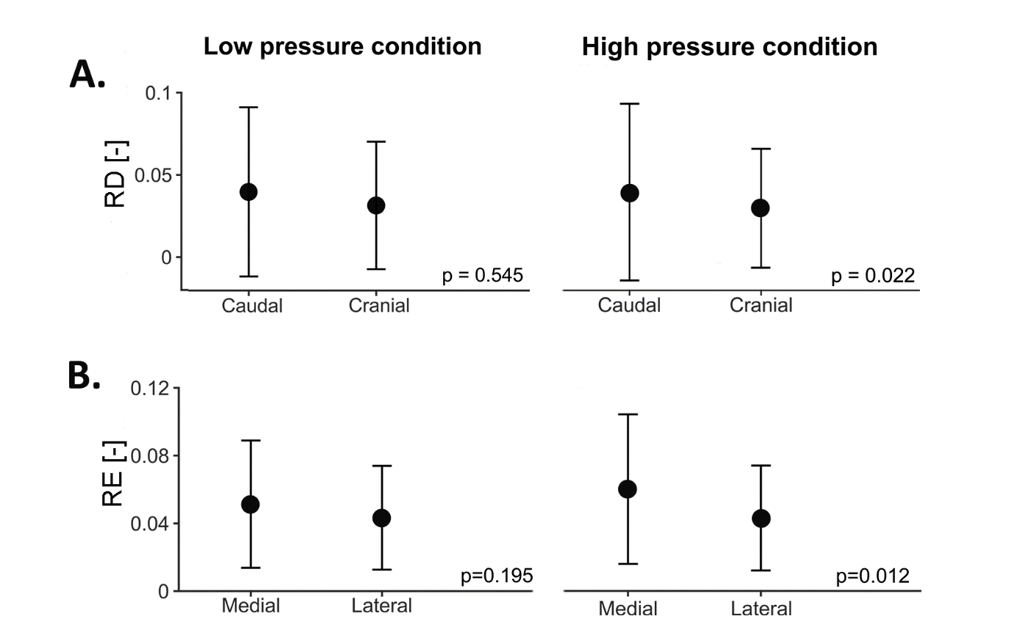
Figure 2. Comparison between - (A) relative distensions (RD) of caudal and cranial diameters for low and high pressure conditions; (B) relative extensions (RE) of medial and lateral length for low and high pressure conditions; Data presented as mean ± SD.

